Technical Design Document for

Online Retirement Application

Prepared for

**Office of ORA**

Date:

10/5/2018

Version 1.0 Draft

**Prepared by**

**Donovan Goode – Business Applications Technology Solutions Professional**

**Contributors**

Revision and Signoff Sheet

Change Record

|  |  |  |  |
| --- | --- | --- | --- |
| Date | Author | Version | Change Reference |
|  |  |  |  |
|  |  |  |  |
|  |  |  |  |
|  |  |  |  |

Reviewers

|  |  |  |  |
| --- | --- | --- | --- |
| Name | Version Approved | Position | Date |
| Patrick McGowen |  |  |  |
| Chris Geer |  |  |  |
|  |  |  |  |

Table of Contents

Purpose and Scope 6

Abbreviations and Glossary of Technical Terms 7

Assumptions and Constraints 7

1 Solution Overview 8

2 Environment Constraints and Assumptions 9

3 Dynamics 365 (CRM) Application DevelORAent 10

3.1 Site Map 10

Entities related to the Site Map 11

3.2 Entity Configuration 11

Entities 11

3.2.1 Entity Relationship Diagram 12

3.2.2 Component [Agency] Entity Design 13

3.2.3 Component [Contact] Entity Design 13

3.2.4 Component [Package] Entity Design 14

3.2.5 Component [Invitation] Entity Design 14

3.2.6 Component [Service History] Entity Design 15

3.2.7 Component [Required Document] Entity Design 15

3.2.8 Component [Supporting Document] Entity Design 16

3.3 Business Services (Business Logic) 16

3.3.1 Workflows 17

3.4 Business Processes and Settings 17

3.4.1 SLAs 17

3.4.2 Routing Rules 18

3.4.3 E-Mail Routing 18

3.5 Business Settings 18

3.6 Business Management 18

3.6.1 Fiscal Year Settings 18

3.6.2 Queues 18

3.6.3 Subjects 18

3.6.4 Automatic Creation Rules and Routing 18

3.7 Administration Settings 18

3.7.1 System Settings 18

3.7.2 Privacy Preferences 19

3.7.3 System Notifications 19

3.7.4 Azure Machine Learning 19

3.7.5 Auto-Numbering 19

3.7.6 Languages 19

3.7.7 Resources in Use 19

3.8 Data 19

3.8.1 Document Migration 19

3.8.2 Structured Data Migration or reference to data mapping spreadsheet(s) 19

3.8.3 Reporting 19

3.8.4 Excel Business Analysis 19

3.8.5 Application Security Architecture 21

3.9 Internal ORA ORA Users 22

3.10 Business units 22

3.11 Teams 22

3.12 Security Roles 22

3.13 External ORA ORA Portal Users 22

## Purpose and Scope

The purpose of this document is to outline the technical design for the ORA ORA System. The PoC demonstrates how to achieve the ORA ORA requirements utilizing the Microsoft Dynamics 365 platform.

The purpose of this document can be summarized as follows:

* It describes the high-level technical design
* It describes the system configurations and customizations used in the designs
* It has been an input to the functional tests for the solution
* It can be used to support future develORAent and enhancements

The document also describes the security model, entity data model along with the associated logical components designed and developed to meet the requirements gathered by the Microsoft Team when demonstrating the prototypes.

The intended audience for this document is:

* Developer(s)
* Tester(s)
* Support team
* Architect(s)

The intended audience for this document should have a basic technical understanding of the Microsoft Dynamics 365 product.

## Abbreviations and Glossary of Technical Terms

|  |  |
| --- | --- |
| Abbreviation | Explanation |
| CRM | Customer Relationship Management |
| OOB | Out of the box |
| ORA | Online Retirement Application |
| SaaS | Software as a Service |

## Assumptions and Constraints

|  |  |  |
| --- | --- | --- |
| Sl. No. | Assumption/Constraint | Details |
|  |  |  |
|  |  |  |
|  |  |  |
|  |  |  |
|  |  |  |

1. Solution Overview

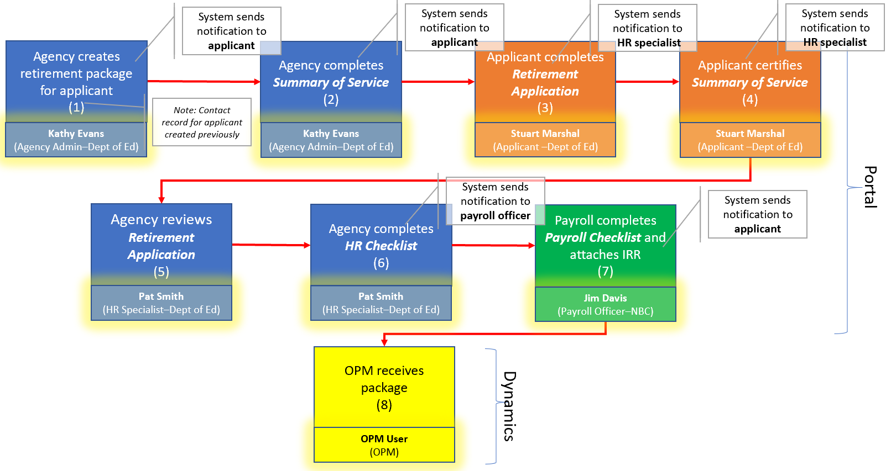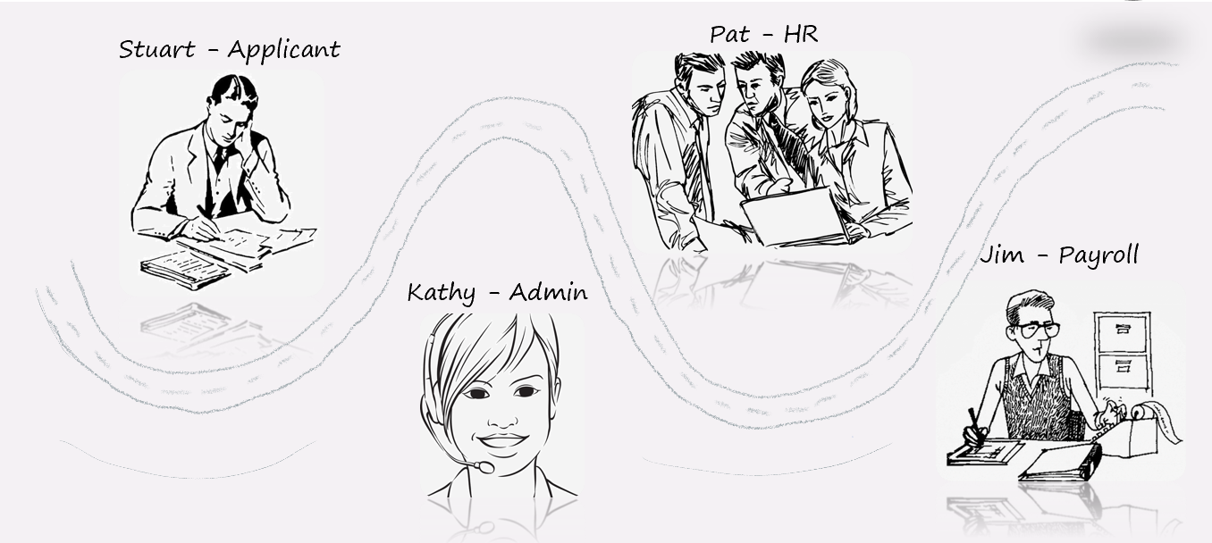

1. Environment Constraints and Assumptions

Dynamics 365 is a purchased and licensed product. The ORA ORA Application is leveraging Dynamics 365 CE for GCC and a Dynamics 365 Portal.

1. Dynamics 365 (CRM) Application Development



Portals

Configuration, Customization

Content Management

* 1. Site Map

The menu structure for ORA ORA is based on the groups of individuals using the system such as the Branch Manager, Gate Keeper, Supply Manager, and the Budget Execution Manager.

### 

### Entities related to the Site Map

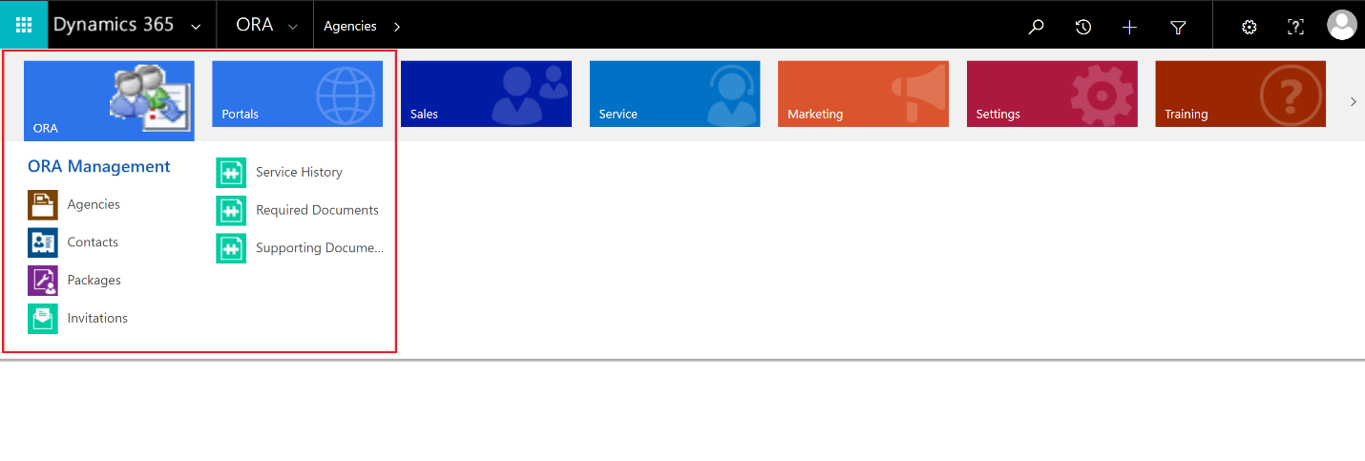

#### Dynamics 365 Security Role Settings related to the Sitemap and Solution

These are the following security roles that have been configured to control access to various dashboards on the Sitemap, and various forms as well:

* 1. Entity Configuration

### Entities

* Agency
* Contact
* Package
* Invitation
* Service History
* Required Document
* Supporting Document
  + 1. Entity Relationship Diagram

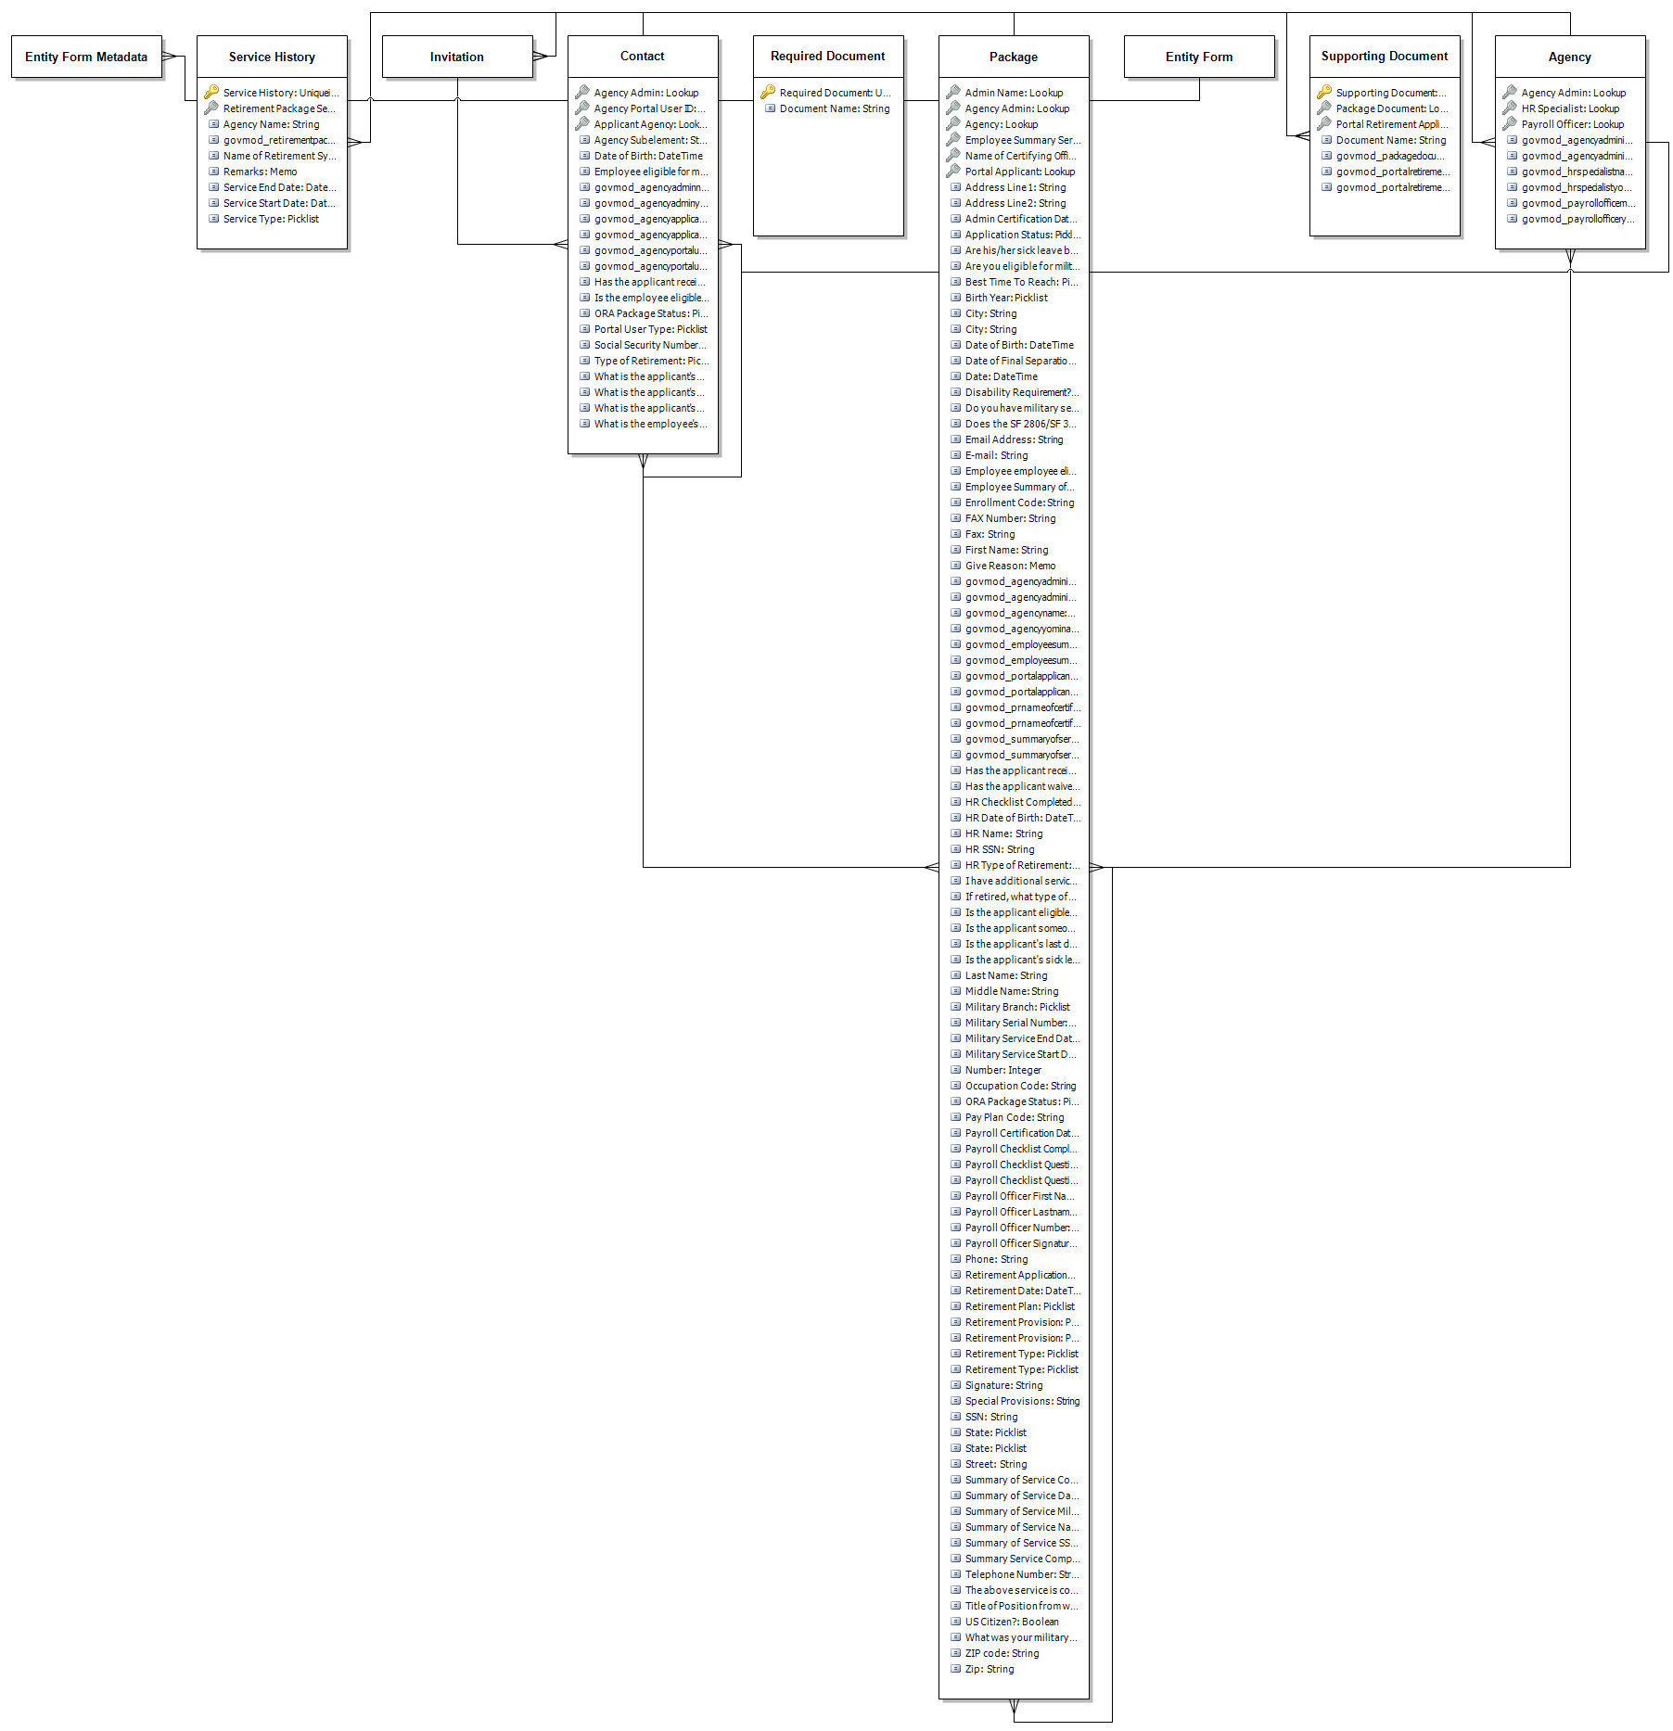

* + 1. Component [Agency] Entity Design

#### Behavioral Summary

The ORA ORA Record is the central entity of the system and is the parent of numerous child entities including but not limited to applications, beneficiaries, payments, appeals, and activities.

#### Relationships

#### Forms

#### Business Rules

#### Form Based Scripting

#### Views

#### Charts

#### New Error Messages

#### Field Level Security Implementation

* + 1. Component [Contact] Entity Design

#### Behavioral Summary

The application entity captures information based on the applicant’s perspective. This information is then reviewed for accuracy by the resource center team and then incorporated into the PSO Record.

#### Relationships

Forms

Business Rules

#### Form Based Scripting

Views

Charts

#### New Error Messages

#### Field Level Security Implementation

* + 1. Component [Package] Entity Design

#### Behavioral Summary

The Contact Record is used for any individual person including but not limited to beneficiaries, external users, applications, claimants, legal guardians and others.

#### Relationships

Forms

Business Rules

#### Form Based Scripting

Views

Charts

#### New Error Messages

#### Field Level Security Implementation

* + 1. Component [Invitation] Entity Design

#### Behavioral Summary: The activity pointer is a summary/header for all entities that are of type activity. It is used by the system OOB to organize activities for distribution to the end user through OOB interfaces.

#### Relationships

Forms

Business Rules

#### Form Based Scripting

Views

Charts

#### New Error Messages

#### Field Level Security Implementation

* + 1. Component [Service History] Entity Design

#### Behavioral Summary

#### Relationships

Forms

Business Rules

#### Form Based Scripting

Views

Charts

#### New Error Messages

#### Field Level Security Implementation

* + 1. Component [Required Document] Entity Design

#### Behavioral Summary:

#### Relationships

1 to N Relationships

N to 1 Relationships

Forms

Business Rules

#### Form Based Scripting

There is no custom form based scripting on the appeals entity

Views

Fields

Charts

#### New Error Messages

#### Field Level Security Implementation

* + 1. Component [Supporting Document] Entity Design

#### Behavioral Summary:

Fields

#### Relationships

Forms

Business Rules

#### Form Based Scripting

Views

Charts

#### New Error Messages

#### Field Level Security Implementation

* 1. Business Services (Business Logic)



* + 1. Workflows

Workflows are leveraged in this solution to perform server side synchronous automated system processes that handle the data flow between the portal front end and the Dynamics CRM back end.

* Create Invitation from Contact
* Create Portal Retirement Package for Employee applicant
* Create Supporting Package Documents
* Email Payroll Package is ready for review
* Email Summary of Service completion to applicant
* Notify Agency that retirement application has been submitted
* Send Invitation
* Set Application Number to Package ID Number
* Set First Name, Middle Name, Last Name and SSN Fields for ORA Package Summary of Service on Create
* Set ORA Package Agency Admin and Agency Lookups
* Update the Package Tracking Status and Notification Bar
  1. Business Processes and Settings
     1. SLAs

As of this update, there are no current SLAs.

* + 1. Routing Rules

As of this update there, are no current routing rules.

* + 1. E-Mail Routing

Server-Side Sync is configured for E-mail routing; supporting the routing of mail sent from ORA ORA to external recipients. Server-Side Sync is configured to send e-mail and receive e-mail using two system accounts.

* 1. Business Settings
  2. Business Management
     1. Fiscal Year Settings
     2. Queues

No queues have been added as of this update.

* + 1. Subjects

No Subjects have been defined as of this update.

* + 1. Automatic Creation Rules and Routing

No rules or routing have been configured as of this update.

* 1. Administration Settings
     1. System Settings

General

Calendar

Formats

* + 1. Privacy Preferences
    2. System Notifications
    3. Azure Machine Learning
    4. Auto-Numbering
    5. Languages
    6. Resources in Use
  1. Data
     1. Document Migration
     2. Structured Data Migration or reference to data mapping spreadsheet(s)
     3. Reporting
     4. Excel Business Analysis

*(Optional pictures, can also just drop examples of how the requests were met with Export to Excel)*







* + 1. Application Security Architecture

Overview



* 1. Internal ORA ORA Users
  2. Business units
  3. Teams
  4. Security Roles
  5. External ORA ORA Portal Users